**Chapter 4**

**CONCEPTUAL FRAMEWORK**

This study entitled CodeTest - A Web Based RPG is a web based edutainment video game that provides learning and at the same time entertainment to students of College of Computer Studies, who have undergone subjects which are Programming 1 and 2. Users of the web based game are required to have their username and password log in on to the game.

After logging in on to the game, they can now create new game, load their previous saved game, change the game’s options or, log out of their specific account. Creating new game and saving afterwards will be saved directly into the database. The game saved can now be used to load their progress every time they save the game.

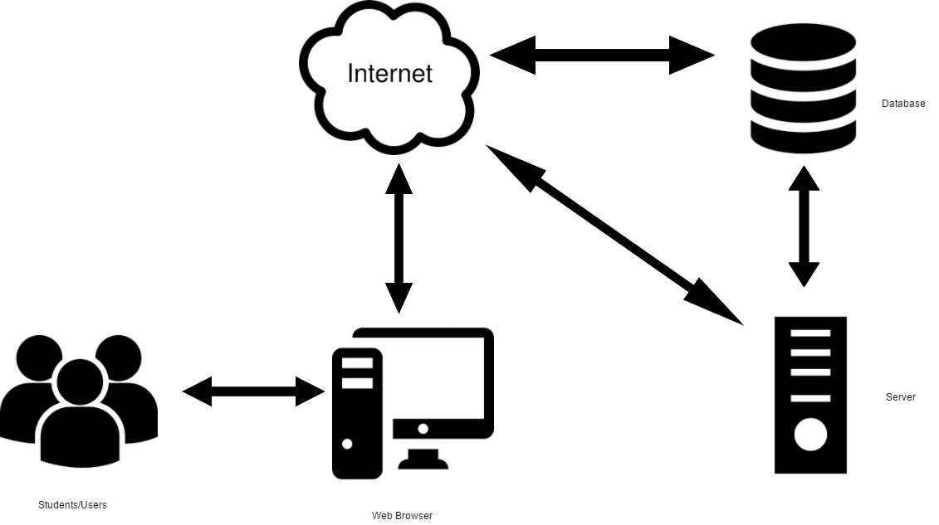

**Figure 1: Conceptual Framework**

As shown in the figure above, the students/users are able to access the game online using a pc that is connected to the internet through a web browser. The web browser connects to the internet which sends the student’s information into the database and the database then verifies the student’s information in the database and then connects to the server which then loads the game into the user’s web browser through the internet.

**Software applications and programming languages used:**

The following are the software and programming languages used by the proponents in developing the system.

**C#**

C# is an elegant and type-safe object-oriented language that enables developers to build a variety of secure and robust applications that run on the .NET Framework. You can use C# to create Windows client applications, XML Web services, distributed components, client-server applications, database applications, and much, much more. Visual C# provides an advanced code editor, convenient user interface designers, integrated debugger, and many other tools to make it easier to develop applications based on the C# language and the .NET Framework.

**LUA**

Lua is a powerful, fast, lightweight and embeddable programming language. It is used by many frameworks, games and other applications. While it can be used by itself, it has been designed to be easy to embed in another application. It is implemented in ANSI C, a subset of the C programming language that is very portable, which means it can run on many systems and many devices where most other scripting languages would not be able to run. Lua comes from two languages that were designed by TeCGraf (a laboratory at the Pontifical Catholic University of Rio de Janeiro): DEL and Sol. DEL means "data entry language", while Sol means "simple object language" and also means sun in Portuguese, which is why the name Lua was chosen, since it means "moon" in Portuguese. It was created for Petrobras, a Brazilian oil company, but was also used in many other projects in TeCGraf, and is now used in a multitude of projects world-wide. Lua is one of the leading languages in the field of embedded game development.

**Unity**

Unity is an all purpose game engine that supports 2D and 3D graphics, drag and drop functionality and scripting through C#. Two other programming languages were supported: Boo, which was deprecated with the release of Unity 5 and UnityScript which was deprecated in August 2017 after the release of Unity 2017.1.The engine targets the following graphics APIs: Direct3D on Windows and Xbox One; OpenGL on Linux, macOS, and Windows; OpenGL ES on Android and iOS; WebGL on the web; and proprietary APIs on the video game consoles. Additionally, Unity supports the low-level APIs Metal on iOS and macOS and Vulkan on Android, Linux, and Windows, as well as Direct3D 12 on Windows and Xbox One. Within 2D games, Unity allows importation of sprites and an advanced 2D world renderer.

**MySQL Workbench**

MySQL Workbench now provides a complete, easy to use solution for migrating Microsoft SQL Server, Microsoft Access, Sybase ASE, PostreSQL, and other RDBMS tables, objects and data to MySQL. Developers and DBAs can quickly and easily convert existing applications to run on MySQL both on Windows and other platforms.

**System Development Model**

The researchers used the Waterfall Model to develop the system. This will help to the development of the proposed project.

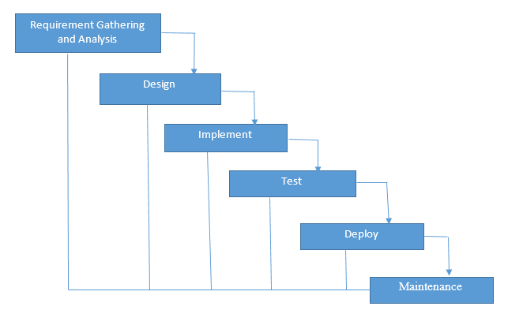

**Figure 2: Code Testing Web Based RPG Development Life Cycle**

**Overview of Phases**

The development team will follow the structure of the Waterfall Model but with its own twist of 6 Phases. Once all the necessary information are gathered and initial requirements determined and defined the project initiation will follow.

***Information Gathering***

During the information gathering phase the development team will determine a project summary, which includes the general overview of the project, organizational background, the environment the organization exist and the people in the organization Goals(objectives) that the site should achieve. The target audience and the messages intended to reach for the target audience.

***Planning***

For the planning phase, all the data that was gathered will be used in constructing up a plan for the system development. This is a critical phase for the software development because this is where the architecture of the system will be based upon.

***Design***

Design phase is another very crucial part of the system development. In this phase the development team must provide a design where the users will be satisfied rather than a very complex system that will result into unsatisfactory rating. This phase deals on how interactive your system to the users and how it gives them the benefits they wanted. Furthermore, each team member and adviser must submit their opinions (likes and dislikes) on the prototype designs so that a more appropriate design will be created.

***Development***

The development phase is the phase where the development team will create the game’s user interface and the game itself. The developers will create the game intended for the CCS students of La Salle University.

***Testing and Delivery***

Checking that the software’s functionality and intended features are good is a must in this phase. The developer must check the entire system for remaining software bugs and errors in order for them to provide the necessary solutions to it. Before the delivery of software, the development team must perform a final checkup and then give the software application with its manual to the client.

***Maintenance***

After delivery, the development team will update if the software is performing well. The maintenance phase also serves as the inspecting the daily or monthly routines of the software and also adding new features to it will happen in this phase.

In developing the Code Testing Web Based RPG (Role Playing Game) the waterfall model serves as guidelines on how to come up with a successful system development. The waterfall model is a step by step procedure on how to develop a system by starting in the first phase down to the last phase. To complete the water fall cycle the first phase should be implemented first before continuing to the other phases. By following these sequence the system will have a successful output at the end of the development the desired outcome of the system will be attained.